Car Rental Service & more

Data engineering 1 - Project Report (Team Green)

**Under the Guidance of**

Professor Frank Hefter

**Submitted By**

Aditya Raj Singh (RS, A)  
Fatemeh Shahriarizadeh (S, F)

Kartikeya Sharma (S, K)

Krupa Jayarame (J, K)

Prutha Kiran Suroshi (KS, P)

Shital Bagankar (B, S)

Tanya Goyal (G, T)

Table of Contents

Contents

**1. Introduction:** 5

2. Organization 7

2.1 Roles and Responsibilities 7

2.2 Meetings 8

2.3 Tools Used 11

3. User Stories 11

3.1 Send help to customer if car is not working in between. 12

3.2 Inform to police if customer does not return the car. 12

3.3 Listing out all the cars that were present at a specific co-ordinate at a given time based on a Police Complaint 12

3.4 Extension of car renting time in current booking. 12

3.5 Getting a driver for the customer. 12

3.6 Finding the cars which crossed a specific city. 12

3.7 Rescheduling the customer booking as per flight schedule. 12

4. Details 12

4.1 Send help to customer if car is not working in between. 12

4.1.1 User Story 12

4.1.2 Identified Use Case 12

4.1.3 Actors 14

4.1.4 Description 14

4.1.5 Data Flow 14

4.1.6 Databases: 14

4.1.7 Databases Used 14

4.1.8 Expression Used 15

4.1.9 Outcome 16

4.2 Inform to police if customer does not return the car. 17

4.2.1 User Story 17

4.2.2 Identified Use Case 17

4.2.3 Actors 19

4.2.4 Description 19

4.2.5 Data Flow 19

4.2.6 Databases: 19

4.2.7 Databases Used 19

4.2.8 Expression Used 20

4.2.9 Outcome 23

4.3 Listing out all the cars that were present at a specific co-ordinate at a given time based on a Police Complaint 24

4.3.1 User Story 24

4.3.2 Identifying Use Case 24

4.3.3 Actors 26

4.3.4 Description 26

4.3.5 Data Flow 26

4.3.6 Databases 26

4.3.7 Database Used 26

4.3.8 Expression Used 26

4.3.9 Outcome 29

4.4 Extension of car renting time in current booking. 30

4.4.1 User Story 30

4.4.2 Identified Use Case 30

4.4.3 Actors 31

4.4.4 Description 31

4.4.5 Data Flow 32

4.4.6 Databases 32

4.4.7 Database Used 32

4.4.8 Expressions Used 33

4.4.9 Outcome 38

4.5 Getting a driver for the customer. 42

4.5.1 User Story 42

4.5.2 Identified Use Case 42

4.5.3 Actors 43

4.5.4 Description 43

4.5.5 Data Flow 43

4.5.6 Databases 44

4.5.7 Database Used 44

4.5.8 Expressions Used 44

4.5.9 Outcome 47

4.6 Rescheduling the customer booking as per flight schedule. 48

4.6.1 User Story 48

4.6.2 Identified Use Case 48

4.6.3 Actors 50

4.6.4 Description 50

4.6.5 Data Flow 50

4.6.6 Databases 50

4.6.7 Database Used 50

4.6.8 Expressions Used 51

4.6.9 Outcome 53

4.7 Finding the cars which crossed a specific city. 54

4.7.1 User Story 54

4.7.2 Identified Use Case 54

4.7.3 Actors 55

4.7.4 Description 55

4.7.5 Data Flow 56

4.7.6 Databases 56

4.7.7 Database Used 56

4.7.8 Expressions Used 56

4.7.9 Outcome 56

5. Databases 57

5.1 Overall Structure 57

6. Application 57

6.1 Languages Used 57

6.2 GitHub path 58

7. Evaluation 58

7.1 Outlook 58

7.2 Lessons Learnt 58

7.3 Possible Extensions 58

8 References 59

List of Tables

Table 1: Roles and Responsibilities 6

Table 2: Responsibilities Definition 6

Table 3: Meeting 1 7

Table 4: Meeting 2 7

Table 5: Meeting 3 8

Table 6: Meeting 4 8

Table 7: Meeting 5 9

Table 8: Meeting 6 9

Table 9: Tools Used 10

List of Figures

Figure 1: Use Case 1 - UML 12

Figure 2: Use Case 1 - Interaction Diagram 13

Figure 3: Use Case 1 - DFD 14

Figure 4: Use Case 1 - Expression Used 16

Figure 5: Use Case 1 - Python Script Output 16

Figure 6: Use Case 1 – Neo4j Output 16

Figure 7: Use Case 2 – UML 17

Figure 8: Use Case 2 – Interaction Diagram 18

Figure 9: Use Case 2 – DFD 19

Figure 10: Use Case 2 – Expressions Used 21

Figure 11: Use Case 2 – MongoDB Output 22

Figure 12: Use Case 2 – Python script Output 23

Figure 13: Use Case 3 – UML 24

Figure 14: Use Case 3 – Interaction Diagram 24

Figure 15: Use Case 3 – DFD 25

Figure 16: Use Case 3 – Expressions Used 28

Figure 17: Use Case 3 – Python Script Output 28

Figure 18: Use Case 4 – UML 29

Figure 19: Use Case 4 – Interaction Diagram 30

Figure 20: Use Case 4 – DFD 31

Figure 21: Use Case 4 – Expressions Used 36

Figure 22: Use Case 4 – MongoDB Output 40

Figure 23: Use Case 4 – Python script Output 40

Figure 24: Use Case 5 – UML 41

Figure 25: Use Case 5 – Interaction Diagram 42

Figure 26: Use Case 5 – DFD 43

Figure 27: Use Case 5 – Expressions Used 46

Figure 28: Use Case 5 – MongoDB Output 46

Figure 29: Use Case 5 – Python Script Output 47

Figure 30: Use Case 6 – UML 48

Figure 31: Use Case 6 – Interaction Diagram 48

Figure 32: Use Case 6 – DFD 49

Figure 33: Use Case 6 – Expressions Used 52

Figure 34: Use Case 6 – MongoDB Output 52

Figure 35: Use Case 6 – Python Script Output 53

# 1. Introduction:

In today’s times, not everyone can afford to own and maintain vehicles, so often they turn to renting one instead. This not only provides an effective option for travel, but also gives a luxury to experience premium vehicles which cannot be owned by everyone. To rent a vehicle of their choice, people generally go to car rental firms in order to find the right vehicle for their needs. This can take up a lot of time and energy. To simplify this process and make it more convenient for customers, there is an increasing need for a platform that allows people to easily search for rental cars with minimal effort. This can be especially important during busy times of the year, when people need reliable, comfortable transportation to get them to their destinations on time.

The “Car Rental System” is intended to give a digital platform to the daily activities and transactions in a car rental business and its customers. This project is an online portal that displays cars for rent. It is a digital system that allows car owners to upload and post the details of their cars for rent and users can go through the available cars that will cater to their requirements and book a vehicle of their choice as well according to their time. This system eliminates the effort required and time consumed in traditional car rental service, where the user must personally visit such firms to rent a vehicle.

# 2. Organization

## 2.1 Roles and Responsibilities

|  |  |  |  |  |  |  |  |
| --- | --- | --- | --- | --- | --- | --- | --- |
| **Tasks** | **Team Members** | | | | | | |
| **RS, A** | **S, F** | **S, K** | **J, K** | **KS, P** | **B, S** | **G, T** |
| Brainstorming | R | R | R | R | R | R | R |
| Requirements Gathering | R | R | R | R | R | R | R |
| Selection of Databases | R | R | R | R | R | R | R |
| Data Setup | R | R | R | R | R | R | R |
| Databases Setup | R | R | R | R | R | R | R |
| UML Diagram | R | R | R | R | R | R | R |
| Data Flow Diagram | R | R | R | R | R | R | R |
| Report Documentation | R | R | R | R | R | R | R |
| User Stories | R | R | R | R | R | R | R |
| Use Case 1 | C | C | R | C | C | C | C |
| Use Case 2 | C | C | C | R | C | C | C |
| Use Case 3 | R | C | C | C | C | C | C |
| Use Case 4 | C | C | C | C | C | R | C |
| Use Case 5 | C | C | C | C | C | C | R |
| Use Case 6 | C | C | C | C | R | C | C |
| Use Case 7 | C | R | C | C | C | C | C |

Table 1: Roles and Responsibilities

|  |  |
| --- | --- |
| **Responsibilities Definition** | |
| R | Responsible |
| C | Consulted |

Table 2: Responsibilities Definition

## 2.2 Meetings

|  |  |  |
| --- | --- | --- |
| Team Blue – Meeting 1 | | |
| Date: 15/01/2023 | Time: 15:30 – 17:00 | Location: MS Teams |
| Participants | Aditya Raj Singh  Fatemeh Shahriarizadeh  Kartikeya Sharma  Krupa Jayarame  Prutha Kiran Suroshi  Shital Bagankar  Tanya Goyal | |
| Discussion | * Project kick-off * Topic Overview * Possible use cases (Basic level) | |
| Actions | Prepared more ideas about the use cases | |
| Conclusions | Finalized basic use cases to discuss with professor | |

Table 3: Meeting 1

|  |  |  |
| --- | --- | --- |
| Team Blue – Meeting 2 | | |
| Date: 20/01/2023 | Time: 15:30 – 16:03 | Location: MS Teams |
| Participants | Aditya Raj Singh  Fatemeh Shahriarizadeh  Kartikeya Sharma  Krupa Jayarame  Prutha Kiran Suroshi  Shital Bagankar  Tanya Goyal  Prof Frank Hefter | |
| Discussion | * Discussed about the project we took * Need to do total 7 use cases * Got few sources for GPS related data from Professor | |
| Actions | Need to create user story which has some real-world problems which customer and car rental services are facing | |
| Conclusions | To prepare more user stories. | |

Table 4: Meeting 2

|  |  |  |
| --- | --- | --- |
| Team Blue – Meeting 3 | | |
| Date: 23/01/2023 | Time: 10:30 – 16:30 | Location: ARC- 005 |
| Participants | Aditya Raj Singh  Fatemeh Shahriarizadeh  Kartikeya Sharma  Krupa Jayarame  Prutha Kiran Suroshi  Shital Bagankar  Tanya Goyal | |
| Discussion | * Discussed 12 user stories with team * Decided to present this to professor | |
| Actions | Decided to present this to professor | |
| Conclusions | If user stories approved then proceed with the data modelling and system design | |

Table 5: Meeting 3

|  |  |  |
| --- | --- | --- |
| Team Blue – Meeting 4 | | |
| Date: 23/01/2023 | Time: 16:30 – 17:12 | Location: MS Teams |
| Participants | Aditya Raj Singh  Fatemeh Shahriarizadeh  Kartikeya Sharma  Krupa Jayarame  Prutha Kiran Suroshi  Shital Bagankar  Tanya Goyal  Prof. Frank Hefter | |
| Discussion | * Discussed 12 user stories with professor. * Professor modified few user stories so that it may have more advanced problems * And professor gave hints about the new user stories | |
| Actions | 4 user stories accepted and few modified by professor | |
| Conclusions |  | |

Table 6: Meeting 4

|  |  |  |
| --- | --- | --- |
| Team Blue – Meeting 5 | | |
| Date: 24/01/2023 | Time: 11:30 – 16:30 | Location: ARC - 005 |
| Participants | Aditya Raj Singh  Fatemeh Shahriarizadeh  Kartikeya Sharma  Krupa Jayarame  Prutha Kiran Suroshi  Shital Bagankar  Tanya Goyal | |
| Discussion | * After brainstorming created 5 more user stories * Uploaded these user stories to Team blue MS-Teams and got the feedback from the professor * 3 more user stories got approved/modified by professor. | |
| Actions | Need to create the report till 4.x by taking the example of good report shared by professor. | |
| Conclusions | Need to create the report till 4.x by taking the example of good report shared by professor. | |

Table 7: Meeting 5

|  |  |  |
| --- | --- | --- |
| Team Blue – Meeting 6 | | |
| Date: 25/01/2023 | Time: 14:00 – 14:30 | Location: MS-Teams |
| Participants | Aditya Raj Singh  Fatemeh Shahriarizadeh  Kartikeya Sharma  Krupa Jayarame  Prutha Kiran Suroshi  Shital Bagankar  Tanya Goyal | |
| Discussion | * Collected the use cases from the team * Create the report till 4.x and present to professor. | |
| Actions |  | |
| Conclusions | Need to create the report till 4.x by taking the example of good report shared by professor. And share it to professor | |

Table 8: Meeting 6

## 2.3 Tools Used

|  |  |
| --- | --- |
| **Area** | **Tools** |
| Databases | Neo4j Desktop Neo4j Driver MongoDB Driver MongoDB Compass Redis |
| Languages | Python |
| IDE | Visual Studio Code (Python) |
| Version Control | Git GitHub |
| ERD | Visual Paradigm |
| Documentation | Microsoft Word Adobe PDF |
| UML | Visual Paradigm |
| DFD | Lucid Chart |

Table 9: Tools Used

# 3. User Stories

## 3.1 Send help to customer if car is not working in between.

## 3.2 Inform to police if customer does not return the car.

## 3.3 Listing out all the cars that were present at a specific co-ordinate at a given time based on a Police Complaint

## 3.4 Extension of car renting time in current booking.

## 3.5 Getting a driver for the customer.

## 3.6 Finding the cars which crossed a specific city.

## 3.7 Rescheduling the customer booking as per flight schedule.

# 4. Details

# 4.1 Send help to customer if car is not working in between.

## 4.1.1 User Story

As a customer I need help from the Car rental service (Admin) as the car is not working in between. So as an admin will check the GPS location of the customer and the location of the nearest service station of the car rental service and send the help, if the car is not fixed in the given time of span, then a new car will be delivered to the customer from the nearest service station.

## 4.1.2 Identified Use Case

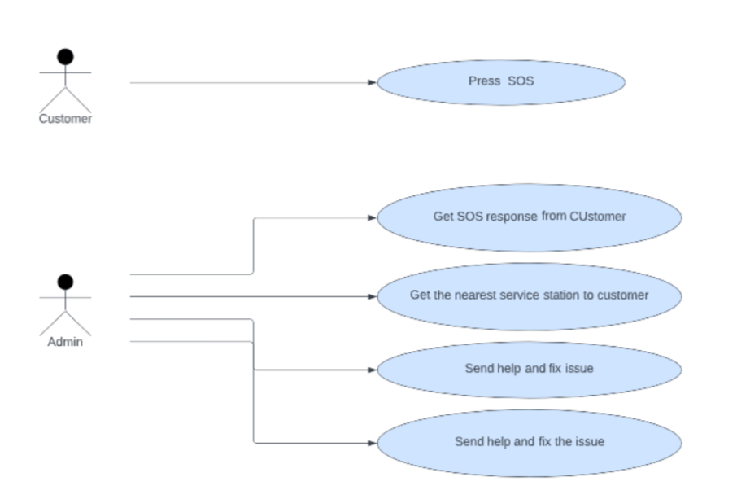

Figure 1: Use Case 1 - UML

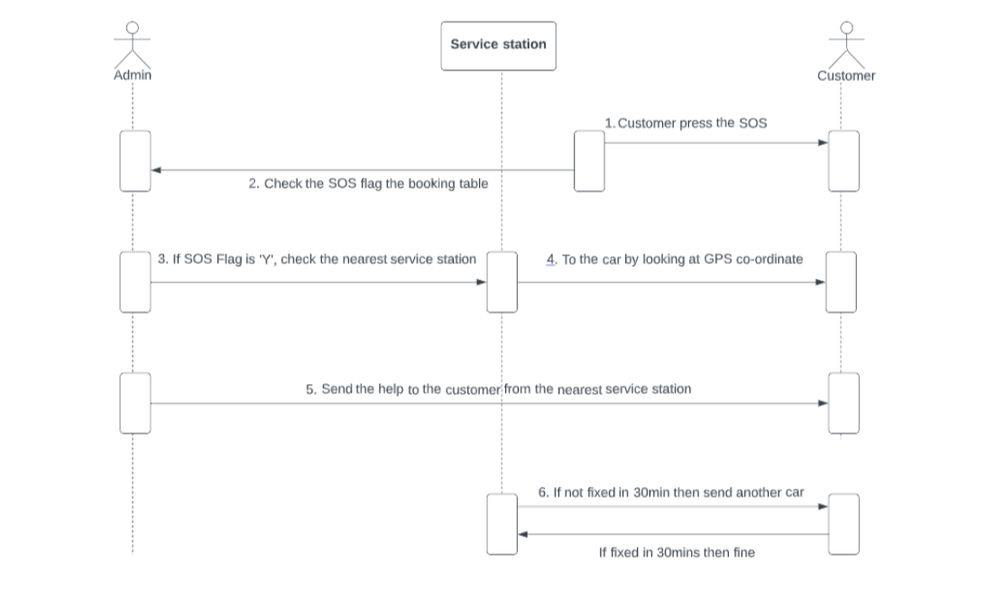

Figure 2: Use Case 1 - Interaction Diagram

## 4.1.3 Actors

• Customer

• Admin (Car rental Service)

## 4.1.4 Description

Customer will send the SOS event to the admin (Car rental Service) and then admin will check the GPS location of the customer and then will send the help from the nearest service Centre, if the car is not fixed within a given time span, then the admin will check the availability of the new car in the nearest service Centre and send it to the customer location.

## 4.1.5 Data Flow

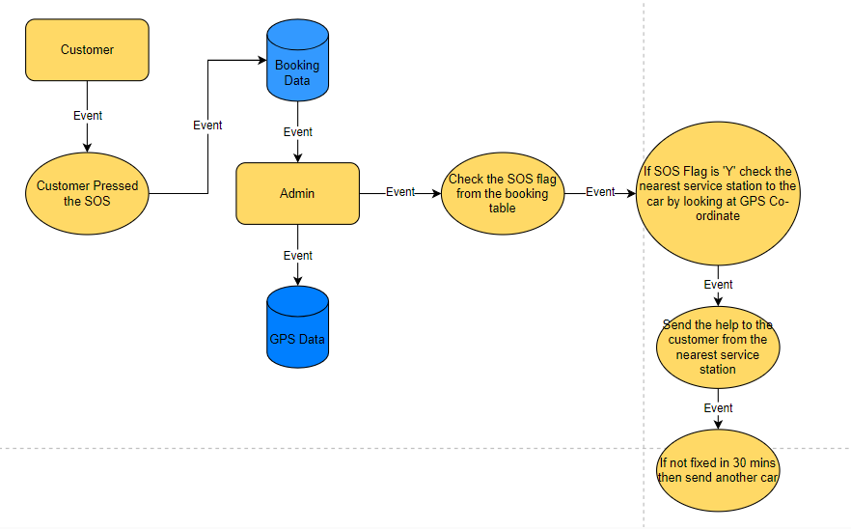

Figure 3: Use Case 1 - DFD

## 4.1.6 Databases:

MongoDB

Neo4j

## 4.1.7 Databases Used

We are using MongoDB as base and presentation layer in Neo4j. As a document database, **MongoDB makes it easy for to store structured or unstructured data** since we are fetching the data for car rental which requires huge amount of GPS data of tracking at every point, so in terms of scalability we used mongodb for this use case.

## 4.1.8 Expression Used

if useCase == '1':

        carservicedata = db.CAR_SERVICE_CENTER.find()

        trackingdata = db.Tracking.find( { "SOS_Flag": "Y" } )

        carservicelist = list(carservicedata)

        trackinglist = list(trackingdata)

        lst2 = []

        d2 = {}

        #for x in trackinglist:

        #    d2['Car_ID'] = 1

        for x in trackinglist:

            #print(x, 'line1')

            lat1 = x["latitude"]

            lon1 = x["longitude"]

            #print(float(lat1), float(lon1))

            d1 = {}

            for y in carservicelist:

                #print(y,'y')

                lat2 = y["S_Latitude"]

                lon2 = y["S_Longitude"]

                d1[y['S_ID']] = round(distance(float(lat1),float(lon1),float(lat2),float(lon2)),2)

                #lst2.append(d1)

                #print(lst2, "d1")

                #break

            #rand_dict.update({i: rand_list.copy()})

            sorted_x = sorted(d1.items(), key=lambda kv: kv[1])

            lst2.append(sorted_x)

            #d2.update({x['Car_ID']: lst2.copy()})

            d2[x['Car_ID']] =  lst2.copy()

            lst2.clear()

            #extracting the closest service center

        lstres = []

        for  x,y in d2.items():

            print(x,y)

            lstres.append(x)

            for p in y:

                print(p)

                for m,n in p:

                    print(m,n)

                    lstres.append(m)

                    lstres.append(n)

                    break

        print(lstres,'lstres--------')

        #neo4Connect(lstres) # calling neo4j to create the relationship

        res = ''

        lstfin = []

        for x in range(0,len(lstres),3):

            res = ''

            res += f"Car_ID : {lstres[x]} "

            res += f"Service_ID : {lstres[x+1]} "

            res += f"Distance : {lstres[x+2]} km"

            #(f"I love {'Geeks'} for \"{'Geeks'}!\"")

            lstfin.append(res)

            print(res)

Figure 4: Use Case 1 - Expression Used

## 4.1.9 Outcome

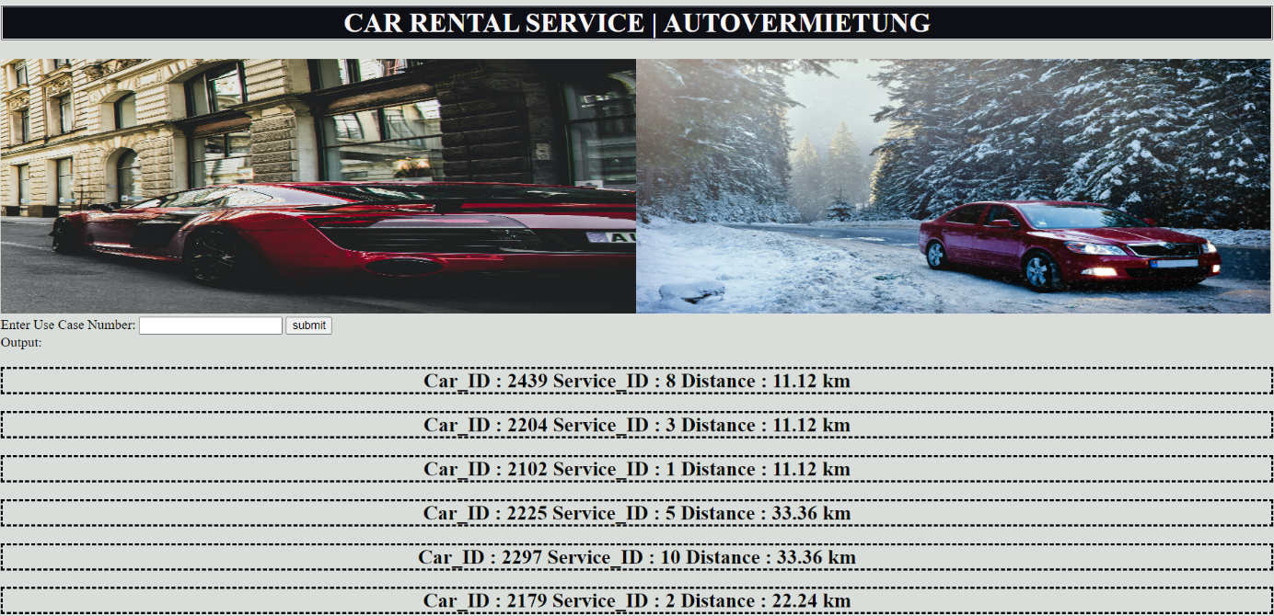

Figure 5: Use Case 1 - Python Script Output

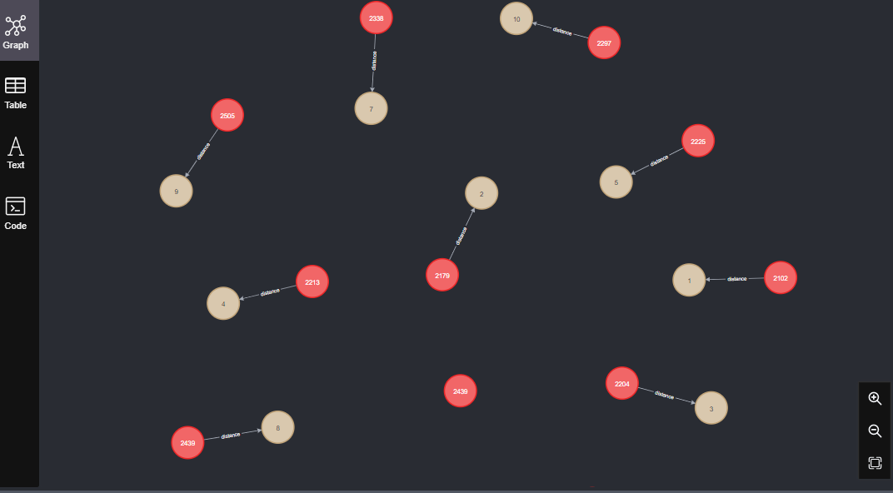

Figure 6: Use Case 1 – Neo4j Output

# 4.2 Inform to police if customer does not return the car.

## 4.2.1 User Story

As an admin I make sure the car is returned by the customer on the mentioned date and time, but the car is not returned on the end rental time. I tried to reach the customer, but the customer is not reachable. So first I have checked the recent GPS co-ordinates of the rented car in our database. and then informed the police

## 4.2.2 Identified Use Case

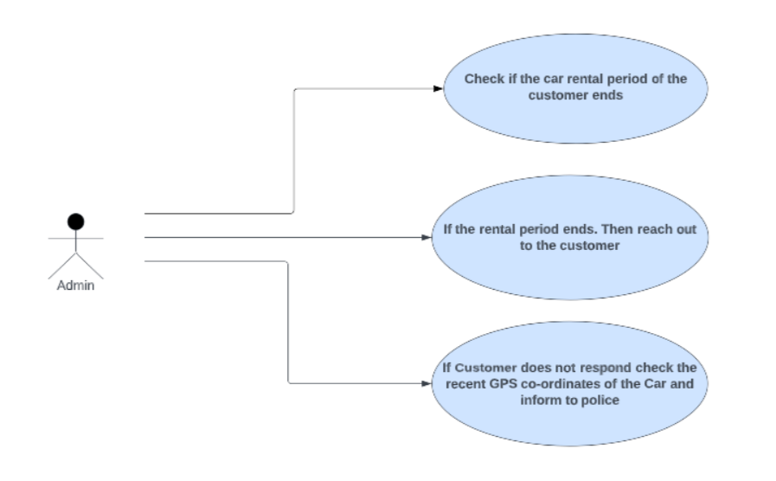

Figure 7: Use Case 2 – UML

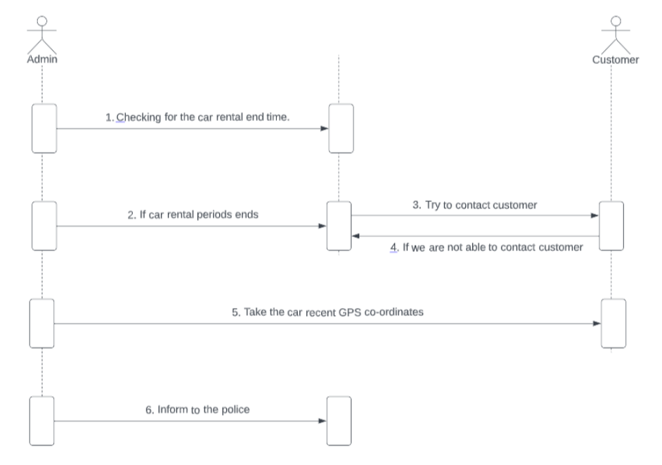

Figure 8: Use Case 2 – Interaction Diagram

## 4.2.3 Actors

• Admin (Car rental Service)

## 4.2.4 Description

As an admin I make sure the car is returned by the customer on the mentioned date and time, but the car is not returned on the end rental time. I tried to reach the customer, but the customer is not reachable. So first I have checked the recent GPS co-ordinates of the rented car in our database. and then informed the police

## 4.2.5 Data Flow

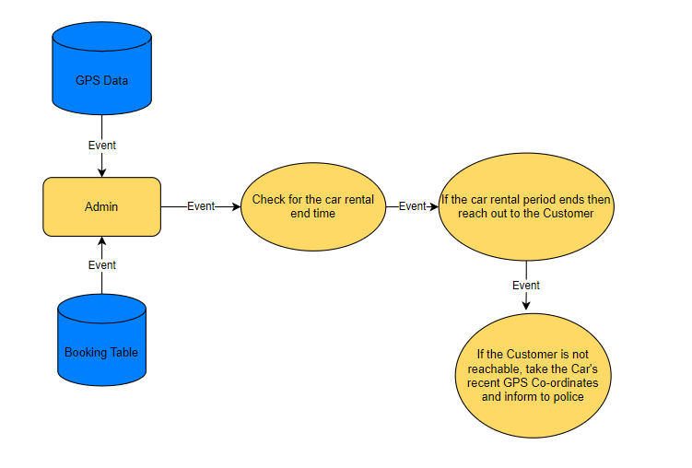

Figure 9: Use Case 2 – DFD

## 4.2.6 Databases:

MongoDB

## 4.2.7 Databases Used

We are using MongoDB as our Database since it delivers data in a high performance applications and integrating large amounts of data.

## 4.2.8 Expression Used

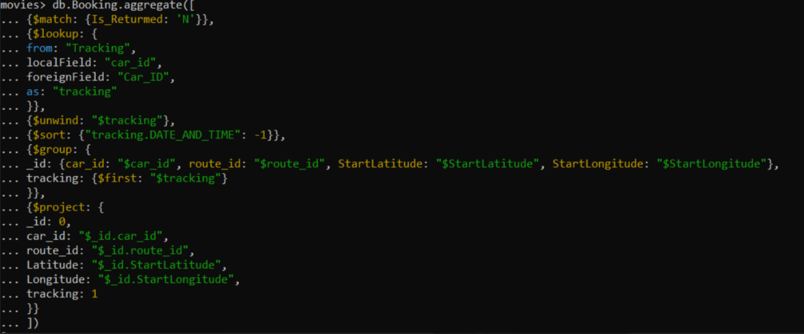

if useCase == '2':

        BookingData = db.Booking.aggregate([

            {

                "$match": {

                    "Is_Returned": "N"

                }

            },

            {

                "$lookup":{

                    "from": "Tracking",

                    "localField": "car_id",

                    "foreignField": "Car_ID",

                    "as": "tracking"

                }

            },

            {

                "$unwind": "$tracking"

            },

            {

                "$sort": {

                    "tracking.DATE_AND_TIME": -1

                }

            },

            {

                "$group": {

                    "_id": {

                        "car_id": "$car_id",

                        "route_id": "$route_id",

                        "StartLatitude": "$StartLatitude",

                        "StartLongitude": "$StartLongitude"

                    },

                    "tracking":{

                        "$first": "$tracking"

                    }

                }

            },

            {

                "$project": {

                    "_id": 0,

                    "car_id": "$_id.car_id",

                    "route_id": "$_id.route_id",

                    "Latitude": "$_id.StartLatitude",

                    "Longitude": "$_id.StartLongitude",

                    "tracking": 1

                }

            }

            ])

        print(BookingData,'BookingData')

        lst3 = []

        for x in BookingData:

            print(x)

            for y in x:

                lst3.append(x[y])

                break

        print(lst3,'lats3')

        lstfin3 = []

        for x in lst3:

            for y in x:

                lstfin3.append(x['Car_ID'])

                lstfin3.append(x['Route_ID'])

                lstfin3.append(x['latitude'])

                lstfin3.append(x['longitude'])

        for x in range(0,len(lstfin3),4):

            res = ''

            res += f"Car_ID : {lstfin3[x]} "

            res += f"Route_ID : {lstfin3[x+1]} "

            res += f"latitude : {lstfin3[x+2]} "

            res += f"longitude : {lstfin3[x+3]} "

            lstfin.append(res)

        s1 = set(lstfin)

        lstfin = list(s1)

Figure 10: Use Case 2 – Expressions Used

## 4.2.9 Outcome

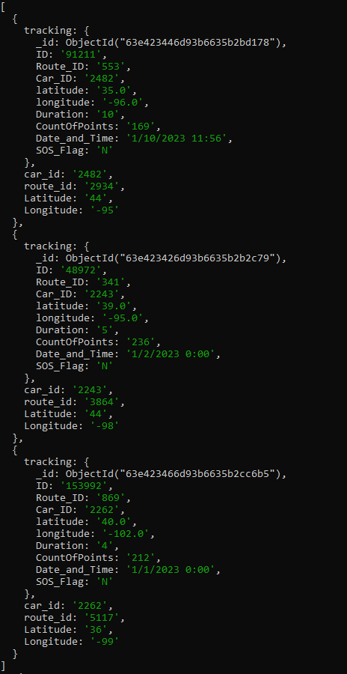

Figure 11: Use Case 2 – MongoDB Output

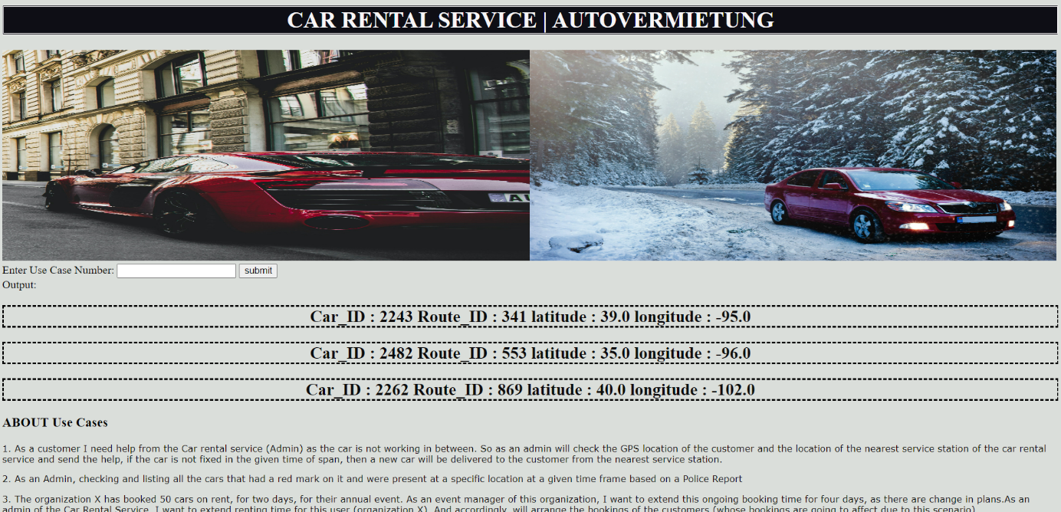

Figure 12: Use Case 2 – Python script Output

# 4.3 Listing out all the cars that were present at a specific co-ordinate at a given time based on a Police Complaint

## 4.3.1 User Story

As an Admin, checking and listing all the cars that had a red mark on it and were present at a specific location at a given time frame based on a Police Report

## 4.3.2 Identifying Use Case

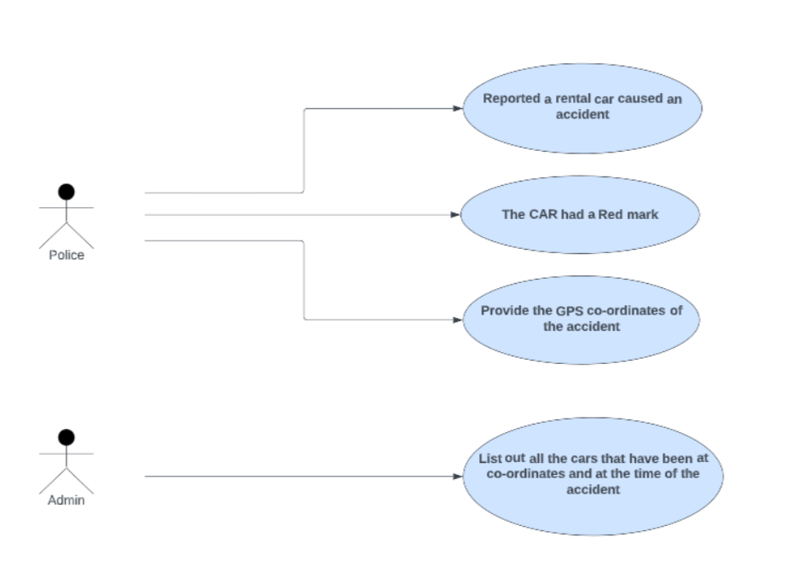

Figure 13: Use Case 3 – UML

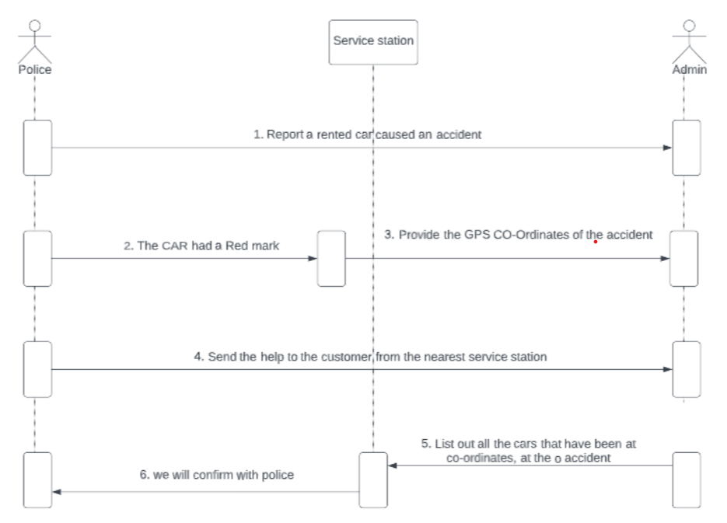

Figure 14: Use Case 3 – Interaction Diagram

## 4.3.3 Actors

* Admin
* Police

## 4.3.4 Description

The Admin of the Car Rental Company has received a Police Report stating one of the rented cars has been suspected to have caused an accident. It has a red mark on it. They have also shared all the details such as time and the co-ordinates of the location.

Based on the information, Admin will check if any of the rented car of our company was present at the time and place of the accident and report back to the police

## 4.3.5 Data Flow

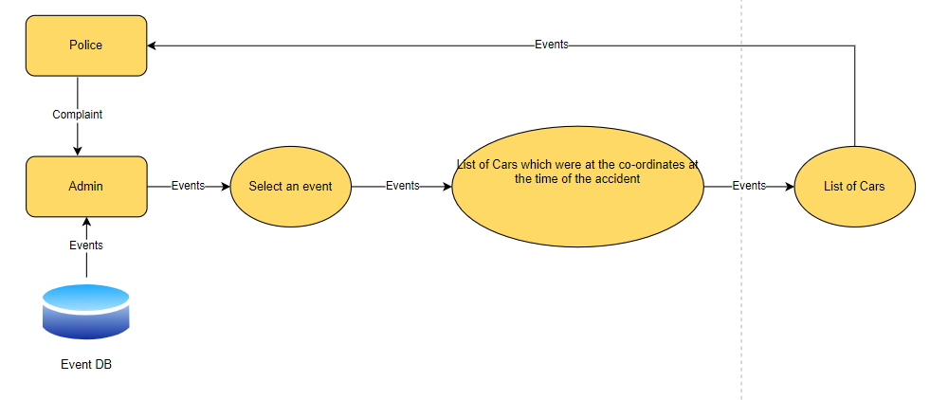

Figure 15: Use Case 3 – DFD

## 4.3.6 Databases

MongoDB

## 4.3.7 Database Used

The main reason to use MongoDB was The [document](https://www.mongodb.com/document-databases) data model is a powerful way to store and retrieve data in any modern programming language, allowing developers to move quickly and JSON has a flexible and dynamic schema, so adding fields or leaving a field out is not a problem.

## 4.3.8 Expression Used

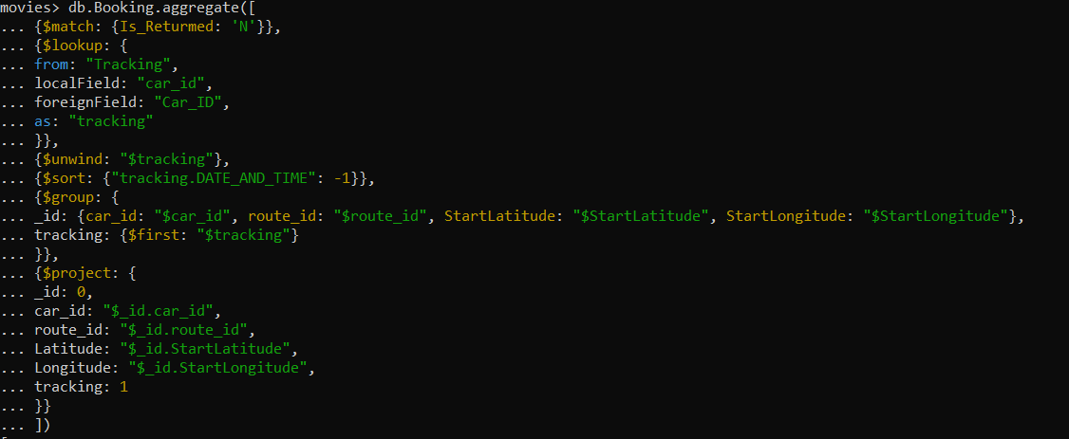

if useCase == '3':

        #lst2.append('Use Case 2')

        lstcarids = []

        #BookingData = db.Booking_Aditya.find( { "Complaint_Flag": "Y" } )

        BookingData = db.Booking_Aditya.aggregate( [

            {

                "$match": {

                    "Complaint_Flag": "Y"

                }

            },

            {

                "$lookup": {

                    "from": "Tracking",

                    "localField": "car_id",

                    "foreignField": "Car_ID",

                    "as": "tracking"

                }

            },

            {

                "$unwind": "$tracking"

            },

            {

                "$sort": {

                    "tracking.DATE_AND_TIME": -1

                }

            },

            {

                "$group":{

                    '_id': {

                        "car_id": "$car_id",

                        "route_id": "$route_id"

                    },

                    "tracking": {

                        "$first": "$tracking"

                    }

                }

            },

            {

                "$project": {

                    '_id': 0,

                    "car_id": "$_id.car_id",

                    "route_id": "$_id.route_id",

                    "tracking": 1

                }

            }

        ] )

        var1 =[]

        lstfin2 = []

        for x in BookingData:

            print(x)

            y = x.values()

            print(y)

            for z in y:

                print(z)

                lstfin2.append(z)

                break

        print(lstfin2,'lstfin2')

        lstfin3 = []

        for x in lstfin2:

            print(x,'x')

            for y in x:

                lstfin3.append(x['Car_ID'])

                lstfin3.append(x['Route_ID'])

                lstfin3.append(x['latitude'])

                lstfin3.append(x['longitude'])

        for x in range(0,len(lstfin3),4):

            res = ''

            res += f"Car_ID : {lstfin3[x]} "

            res += f"Route_ID : {lstfin3[x+1]} "

            res += f"latitude : {lstfin3[x+2]} "

            res += f"longitude : {lstfin3[x+3]} "

            lstfin.append(res)

        s1 = set(lstfin)

        lstfin = list(s1)

Figure 16: Use Case 3 – Expressions Used

## 4.3.9 Outcome

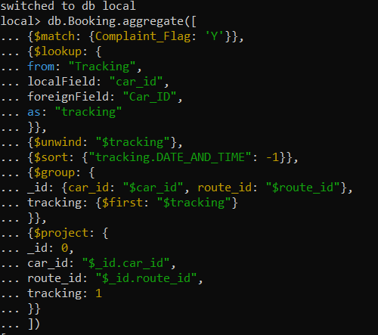

*Figure 15: Use Case 3 – MongoDb Output*

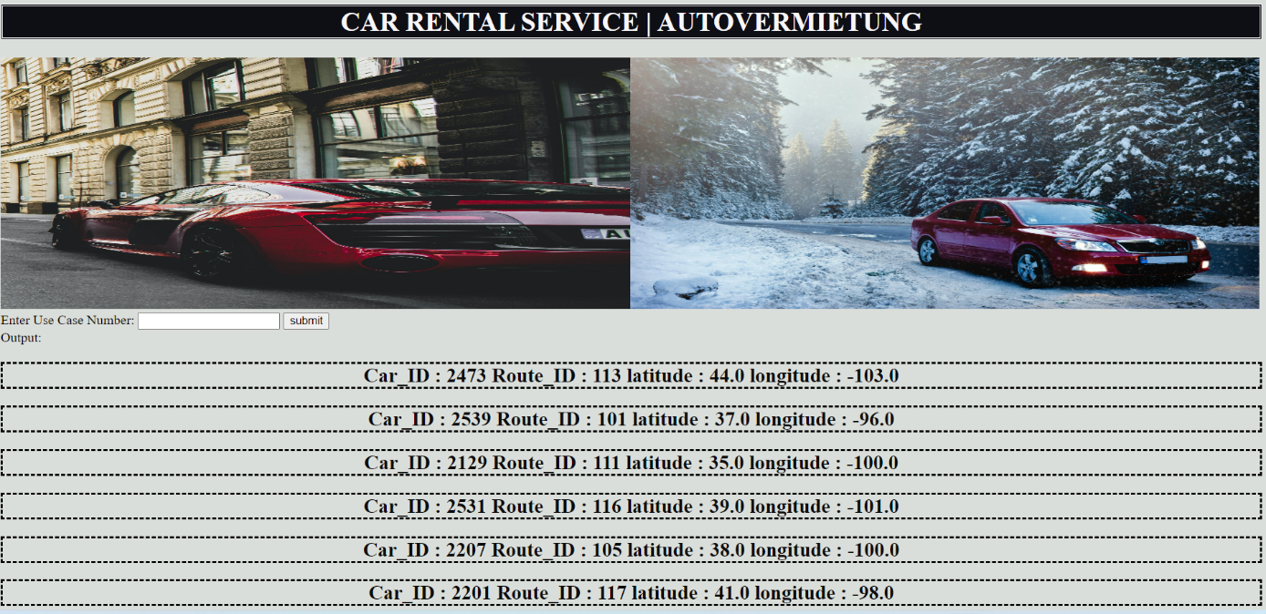

Figure 17: Use Case 3 – Python Script Output

# 4.4 Extension of car renting time in current booking.

## 4.4.1 User Story

The organization X has booked 50 cars on rent, for two days, for their annual event. As an event manager of this organization, I want to extend this ongoing booking time for four days, as there are change in plans.

As an admin of the Car Rental Service, I want to extend renting time for this user (organization X). And accordingly, will arrange the bookings of the customers (whose bookings are going to affect due to this scenario)

## 4.4.2 Identified Use Case

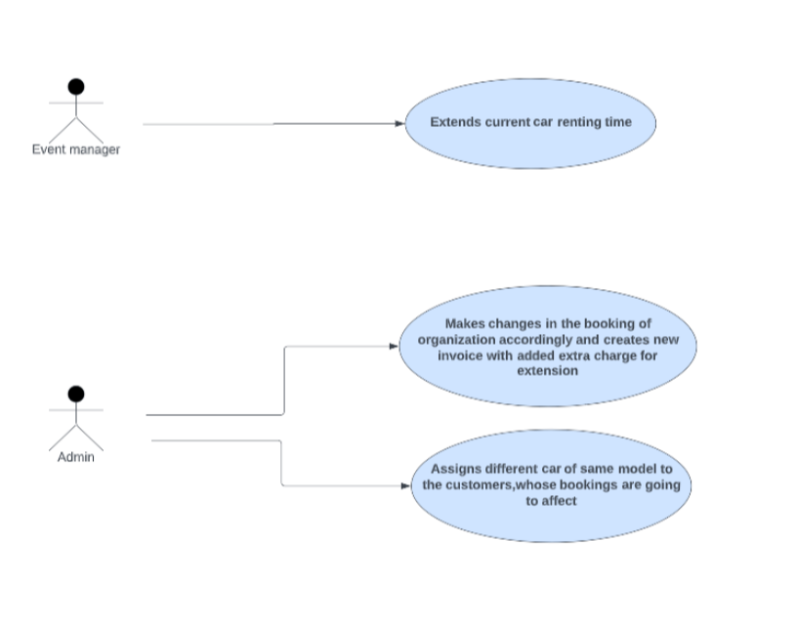

Figure 18: Use Case 4 – UML

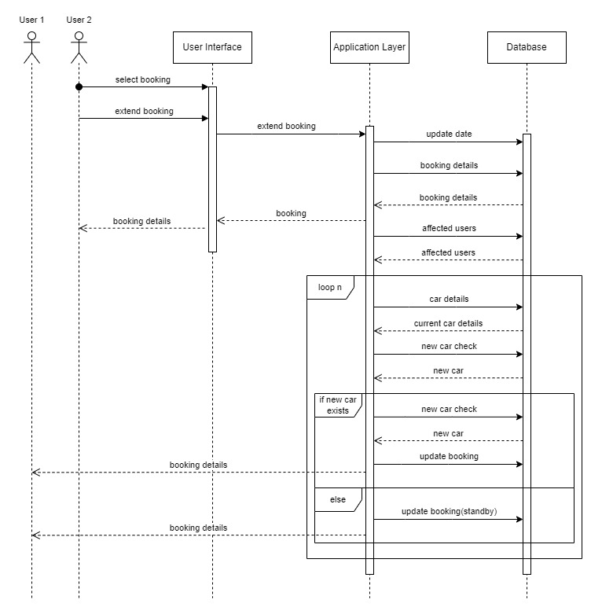

Figure 19: Use Case 4 – Interaction Diagram

## 4.4.3 Actors

• Event manager of the organization X.

• Admin of Car Rental Service.

## 4.4.4 Description

For an annual event, the Organization X booked 50 cars, for two days. Due to change in event plans, they want to extend the renting time from two days to four days.

The admin of the Car Rental Service acknowledges the issue and extends the renting time for this user (organization X). And generates the new invoice, including extra charges for extension. The users, whose booking is going to affected due to this scenario, they will be allotted the same car, the one they previously booked. Unfortunately, if that car is not available, other cars are provided to these users according to their choice.

## 4.4.5 Data Flow

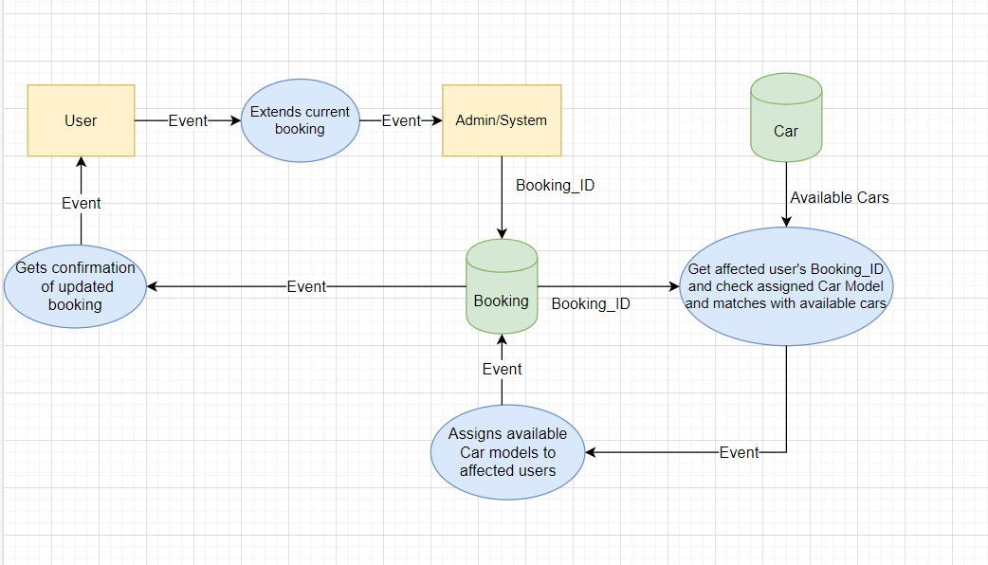

Figure 20: Use Case 4 – DFD

## 4.4.6 Databases

In this use case mainly MongoDB Compass database is used.

## 4.4.7 Database Used

MongoDB’s document-oriented data model makes it suitable for creating update operation and retrieval of feedback when requested. MongoDB is designed to scale horizontally, meaning it can handle large amounts of data and users by simply adding more nodes to the database cluster. This makes it ideal for a car rental service that needs to store and process large amounts of data. It has built-in aggregation framework which helps pulling data into a central database providing a single view of the data.

## 4.4.8 Expressions Used

Following aggregation used to get users data whose booking is affected due to another user's extension in booking ,

db.Booking.aggregate([

    {

        "$match": {

            "User_ID": user_id,

            "Booking_ID": booking_id

        }

    },

    {s

        "$lookup": {

            "from": "Cars",

            "localField": "Car_ID",

            "foreignField": "Car_ID",

            "as": "car"

        }

    },

    {

        "$unwind": "$car"

    },

    {

        "$lookup": {

            "from": "Booking",

            "let": {

                "car_id": "$car.Car_ID",

                "start_date": "$Start_Date",

                "booking_id": "$Booking_ID"

            },

            "pipeline": [

                {

                    "$match": {

                        "$expr": {

                            "$and": [

                                {

                                    "$eq": [

                                        "$Car_ID",

                                        "$$car_id"

                                    ]

                                },

                                {

                                    "$gt": [

                                        "$Start_Date",

                                        "$$start_date"

                                    ]

                                },

                                {

                                    "$ne": [

                                        "$Booking_ID",

                                        "$$booking_id"

                                    ]

                                }

                            ]

                        }

                    }

                }

            ],

            "as": "affected_users"

        }

    },

    {

        "$project": {

            "affected_users": 1

        }

    }

])

   if useCase == '4':

        import datetime

        import isodate

        import json

        from bson.json_util import dumps, loads

        user_id=input("Enter User ID: ")

        booking_id=input("Enter Booking ID: ")

        print("*********Update you booking (ID:"+booking_id+")*********\n\n\n")

        print("*********Please Enter Extension Date(End Date)***********\n")

        end_date = input('Enter a date in YYYY-MM-DD format: ')

        year=int(end_date.split("-")[0])

        month=int(end_date.split("-")[1])

        day=int(end_date.split("-")[2])

        lstfin.append("*********Update your booking (ID:"+booking_id+")*********")

        #end_date=datetime.datetime.strptime(end_date, '%Y-%m-%dT%H:%M:%S.%f')

        updated_booking = {"$set":{"End_Date":end_date}}

        print(updated_booking)

        db.Common_Booking.update_many({"User_ID":user_id},updated_booking)

        booking=list(db.Common_Booking.find({"User_ID":user_id,"Booking_ID":booking_id}))

        affectedCars=[]

        if booking:

            for x in booking:

                affectedCars.append(x["Car_ID"])

        else:

            print("not found")

        db.Cars.update_many({}, [{'$set': {'Start_Date': {'$toDate': '$Start_Date'}}}])

        db.Cars.update_many({}, [{'$set': {'End_Date': {'$toDate': '$End_Date'}}}])

        db.Common_Booking.update_many({}, [{'$set': {'Start_Date': {'$toDate': '$Start_Date'}}}])

        db.Common_Booking.update_many({}, [{'$set': {'End_Date': {'$toDate': '$End_Date'}}}])

        print(list(db.Common_Booking.find({"Car_ID":{"$in":affectedCars},"Start_Date":{"$gt":booking[1]["Start_Date"],"$lte":datetime.datetime(year,month,day,0,0)},"Booking_ID":{"$ne":booking[1]["Booking_ID"]}})))

        affectedUsers=list(db.Common_Booking.find({"Car_ID":{"$in":affectedCars},"Start_Date":{"$gt":booking[1]["Start_Date"],"$lte":datetime.datetime(year,month,day,0,0)},"Booking_ID":{"$ne":booking[1]["Booking_ID"]}}))

        #print(affectedUsers)

        rev1 = affectedUsers.__len__()

        #print("No. of Affected users is: ",affectedUsers.__len__())

        lstfin.append("No. of Affected users is: ")

        lstfin.append('26')

        #print(affectedUsers[1]["Car_ID"])

        for user in affectedUsers:

            #print(user)

            #print(affectedUsers)

            #print(user["Car_ID"])

            matchingcars=list(db.Cars.find({"Car_ID":user["Car_ID"]}))

            #matchingcars=list(db.Car.find({"Car_ID":"2"}))

            #print(matchingcars)

            for car in matchingcars:

                #print(car)

                newcar=list(db.Cars.find({"Car_Manufacturer":car["Car_Manufacturer"],"Status":"Available","Location":user["Pickup_Location"]}))

                #print(newcar[0])

                #print(newcar[0]["Car_ID"])

                #print(user["Booking_ID"])

                if affectedUsers.__len__()!=0:

                    db.Cars.update_many({"Car_ID":newcar[0]["Car_ID"]},{"$set":{"Status":"booked"}})

                    db.Common_Booking.update_many({"Booking_ID":user["Booking_ID"]},{"$set":{"Car_ID":newcar[0]["Car_ID"]}})

                    #print("\n\n Affected users has been assigned a new Car")

                    #lstfin.append("\n\n Affected users has been assigned a new Car")

                    #print("Booking ID :"+user["Booking_ID"], "User ID :"+user["User_ID"], "New Car_ID : "+newcar[0]["Car_ID"])

                else:

                    print("No alternate matching cars are found")

                    lstfin.append("No alternate matching cars are found")

                    db.Common_Booking.update_many({"Booking_ID":user["Booking_ID"]},{"$set":{"Status":"Standby"}})

        #lstfin.append(rev1)

        lstfin.append("Affected users has been assigned a new Car")

Figure 21: Use Case 4 – Expressions Used

## 4.4.9 Outcome

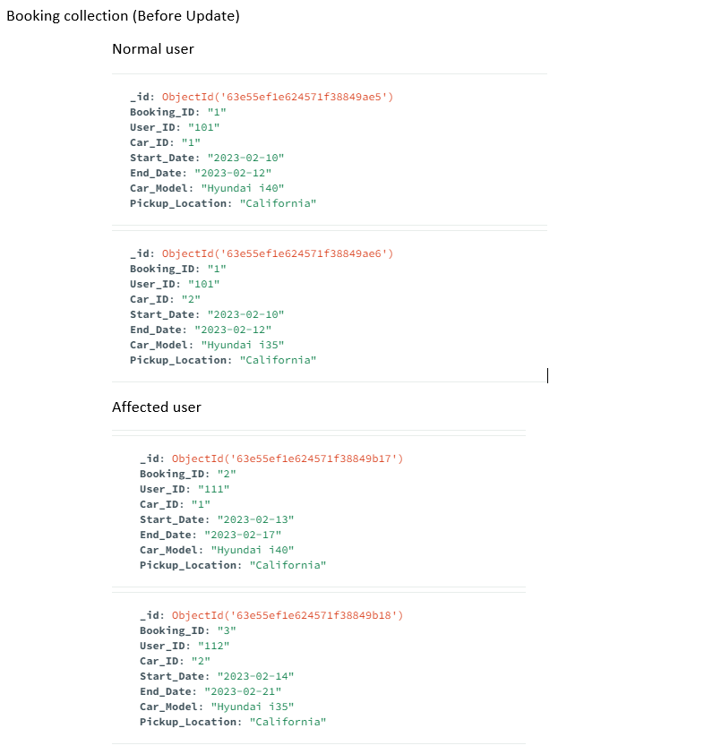

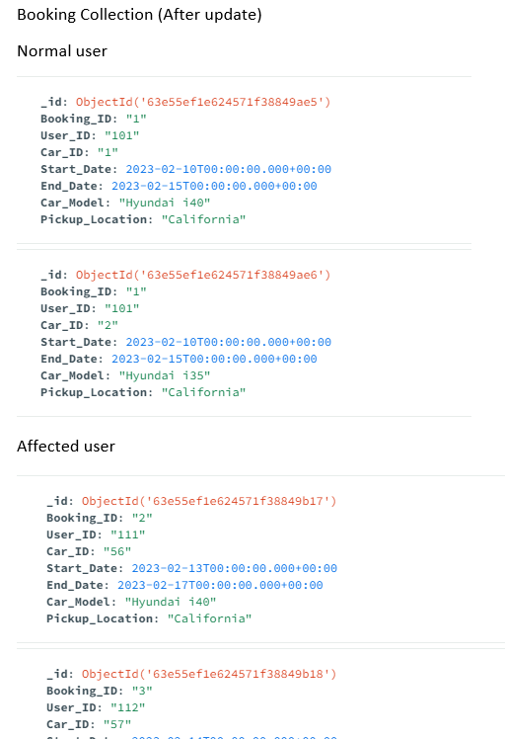

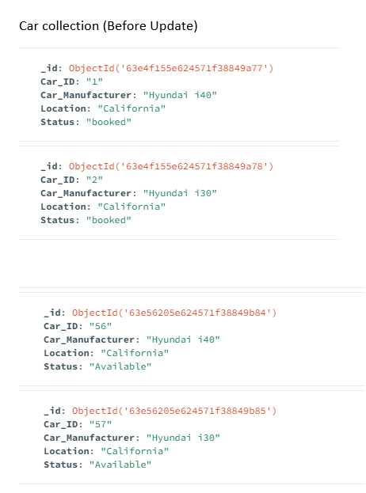

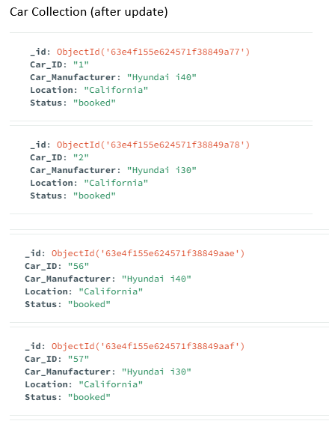

Figure 22: Use Case 4 – MongoDB Output

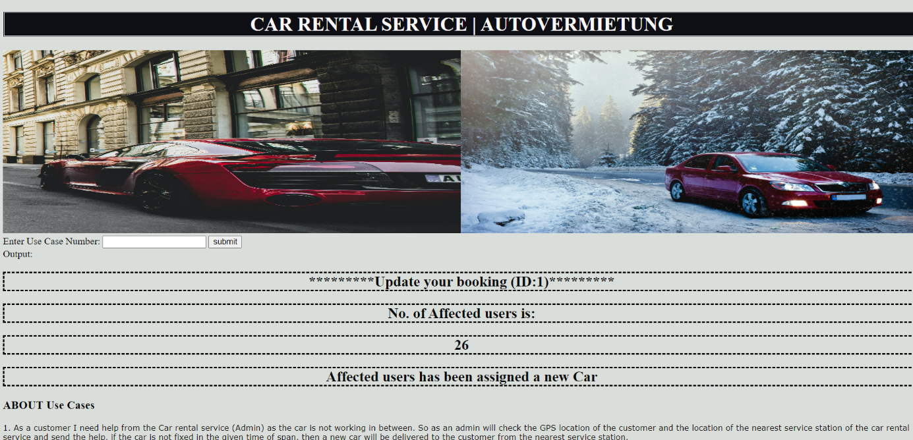

Figure 23: Use Case 4 – Python script Output

# 4.5 Getting a driver for the customer.

## 4.5.1 User Story

As a customer, I want a driver as I can't drive the car. (Neo4j, pool of drivers somewhere, customer and car have to be organized)

## 4.5.2 Identified Use Case

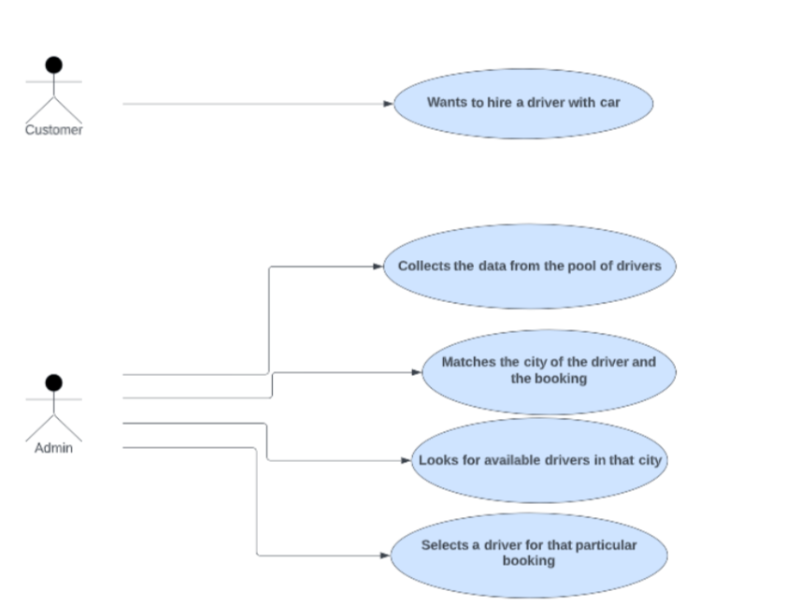

Figure 24: Use Case 5 – UML

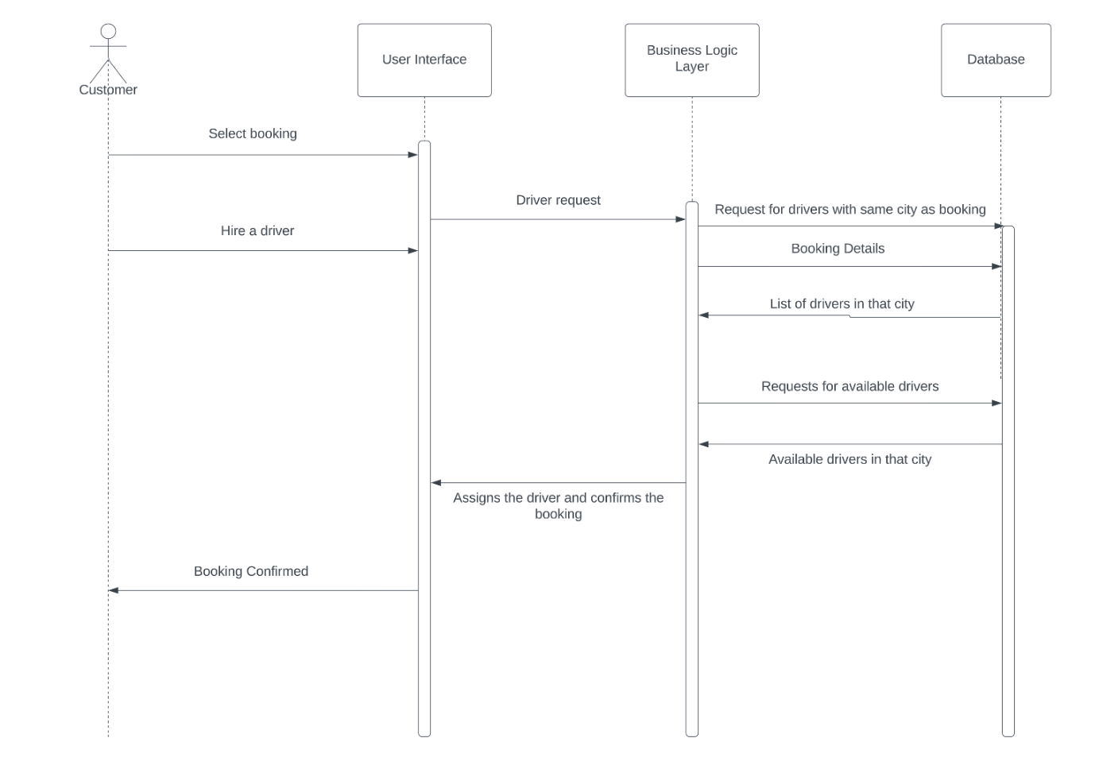

Figure 25: Use Case 5 – Interaction Diagram

## 4.5.3 Actors

• Customer

• Admin (Car rental Service)

## 4.5.4 Description

As a customer, I want a driver as I can't drive the car. (Neo4j, pool of drivers somewhere, customer and car have to be organized)

## 4.5.5 Data Flow

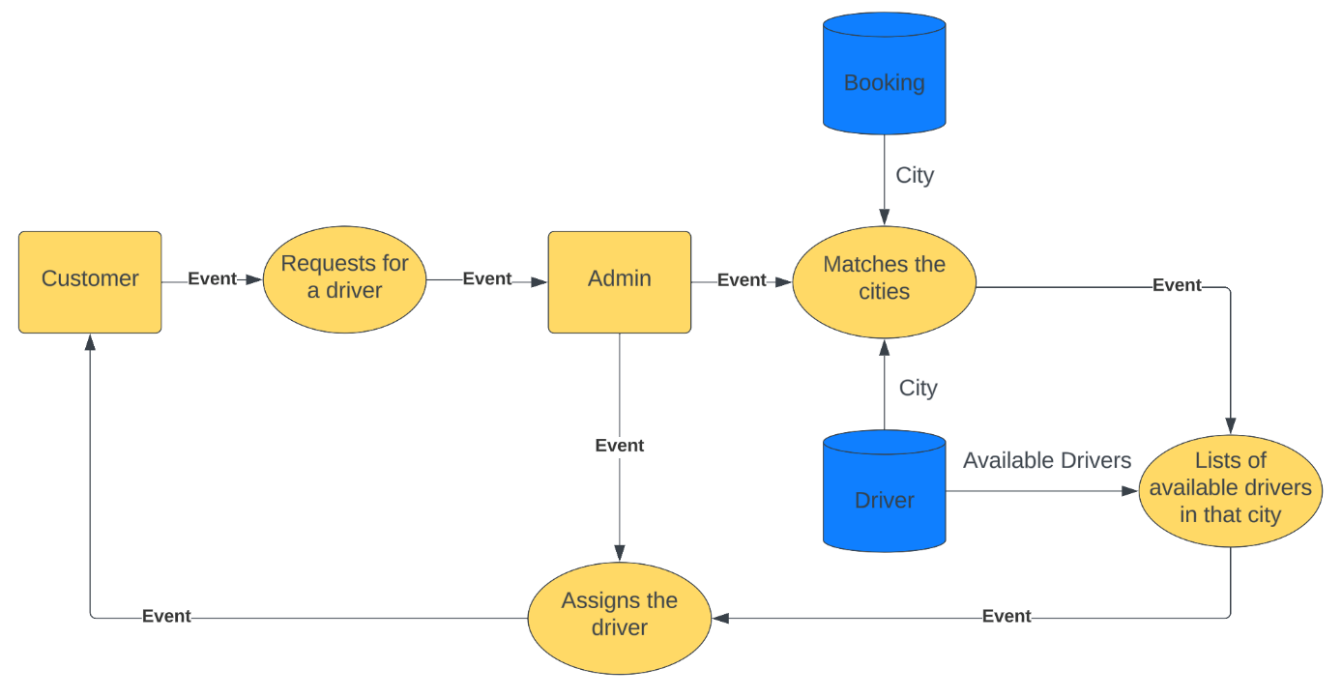

Figure 26: Use Case 5 – DFD

## 4.5.6 Databases

MongoDB Compass is used as a database for this use case. MongoDB’s document-oriented data

model makes it suitable for assigning the driver with the booking of a car.

## 4.5.7 Database Used

MongoDB is designed to scale horizontally, meaning it can handle large amounts of data and users by simply adding more nodes to the database cluster. This makes it ideal for a car rental service that needs to store and process large amounts of data. It allows flexible and dynamic data modeling, has high performance and can handle high read and write loads, making it well suited for real-time updates and queries of driver and booking information.

## 4.5.8 Expressions Used

   if useCase == '5':

        bookingTable = db.Booking_Usecase5

        driverTable = db.Driver

        try:

            bookingWithDriverQuery = bookingTable.find({ "Driver": "Yes" })

            driverStatusQuery = driverTable.find({"Status": "Yes"})

            bookingIdList = []

            driverIdList = []

            for booking in bookingWithDriverQuery:

                bookingDict = {'ID':booking['route id'], 'City': booking['City'], 'Status': booking['BookingStatus']}

                bookingIdList.append(bookingDict)

            for driver in driverStatusQuery:

                driverDict = {'DriverID':driver['DriverID'], 'DriverCity': driver['City']}

                driverIdList.append(driverDict)

            # print(driverIdList)

            assignedlist = []

            notAssignedList = []

            try:

                for bookingId in bookingIdList:

                    flag = 0

                    for driverId in driverIdList:

                        if bookingId['City'] == driverId['DriverCity']:

                            assignedDict = {'BookingID':bookingId['ID'], 'DriverId':driverId['DriverID'], 'City': bookingId['City']}

                            assignedlist.append(assignedDict)

                            bookingTable.update_one({"route id": bookingId['ID']}, {"$set":{"BookingStatus": "Assigned and Confirmed"}})

                            bookingTable.update_one({"route id": bookingId['ID']}, {"$set":{"DriverID": driverId['DriverID']}})

                            driverTable.update_one({"DriverID": driverId['DriverID']}, {"$set":{"Status": "No"}})

                            # bookingIdList.remove(bookingId)

                            driverIdList.remove(driverId)

                            flag+=1

                            break

                    if flag == 0:

                        notAssignedDict = {'BookingID':bookingId['ID'], 'City': bookingId['City']}

                        bookingTable.update_one({"route id": bookingId['ID']}, {"$set":{"BookingStatus": "On hold"}})

                        bookingTable.update_one({"route id": bookingId['ID']}, {"$set":{"DriverID": "Driver not available"}})

                        notAssignedList.append(notAssignedDict)

            except ValueError as e:

                print(e)

        except ValueError as e:

            print(e)

        print('Assigned list')

        print(assignedlist,)

        print("not assigned")

        print(notAssignedList)

        #lstfin.append(assignedlist )

        #lstfin.append(notAssignedList)

        print(len(assignedlist))

        print(len(notAssignedList))

        lstfin3 = []

        #lstfin3.append("Assigned")

        for x in assignedlist:

            for y in x:

                lstfin3.append(x['BookingID'])

                lstfin3.append(x['DriverId'])

                lstfin3.append(x['City'])

        lstfin.append("Assigned")

        for x in range(0,len(lstfin3),3):

            res = ''

            res += f"BookingID : {lstfin3[x]} "

            res += f"DriverId : {lstfin3[x+1]} "

            res += f"City : {lstfin3[x+2]} "

            lstfin.append(res)

        lstfin3 = []

        for x in notAssignedList:

            for y in x:

                lstfin3.append(x['BookingID'])

                #lstfin3.append(x['DriverId'])

                lstfin3.append(x['City'])

        lstfin.append("Not Assigned")

        for x in range(0,len(lstfin3),2):

            res = ''

            res += f"BookingID : {lstfin3[x]} "

            #res += f"DriverId : {lstfin3[x+1]} "

            res += f"City : {lstfin3[x+1]} "

            lstfin.append(res)

        lstfin2 = []

        for x in lstfin:

            if x not in lstfin2:

                lstfin2.append(x)

        lstfin = lstfin2.copy()

Figure 27: Use Case 5 – Expressions Used

## 4.5.9 Outcome

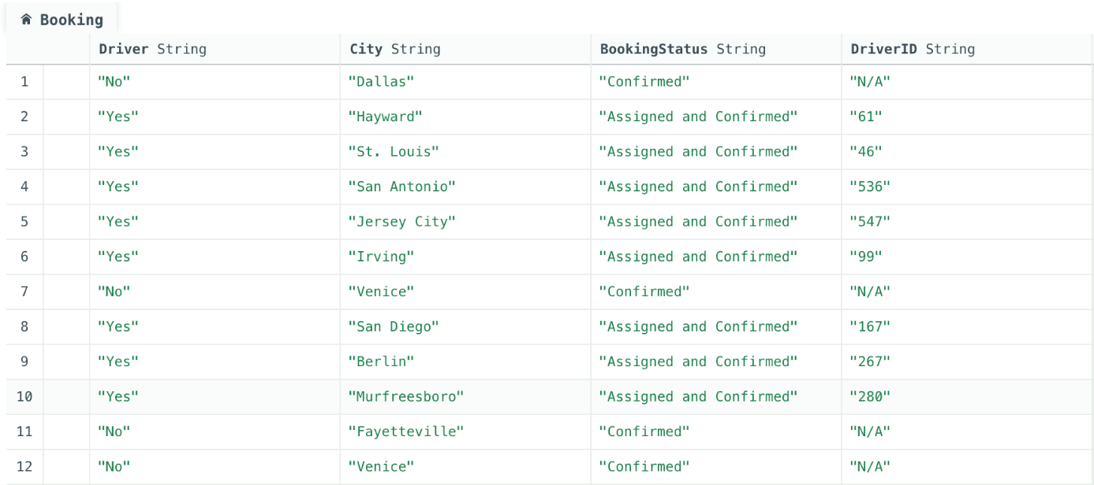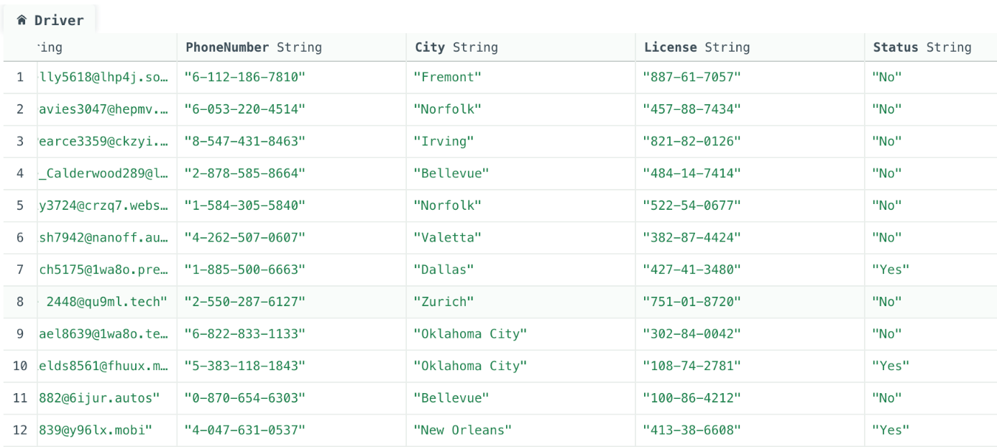

Figure 28: Use Case 5 – MongoDB Output

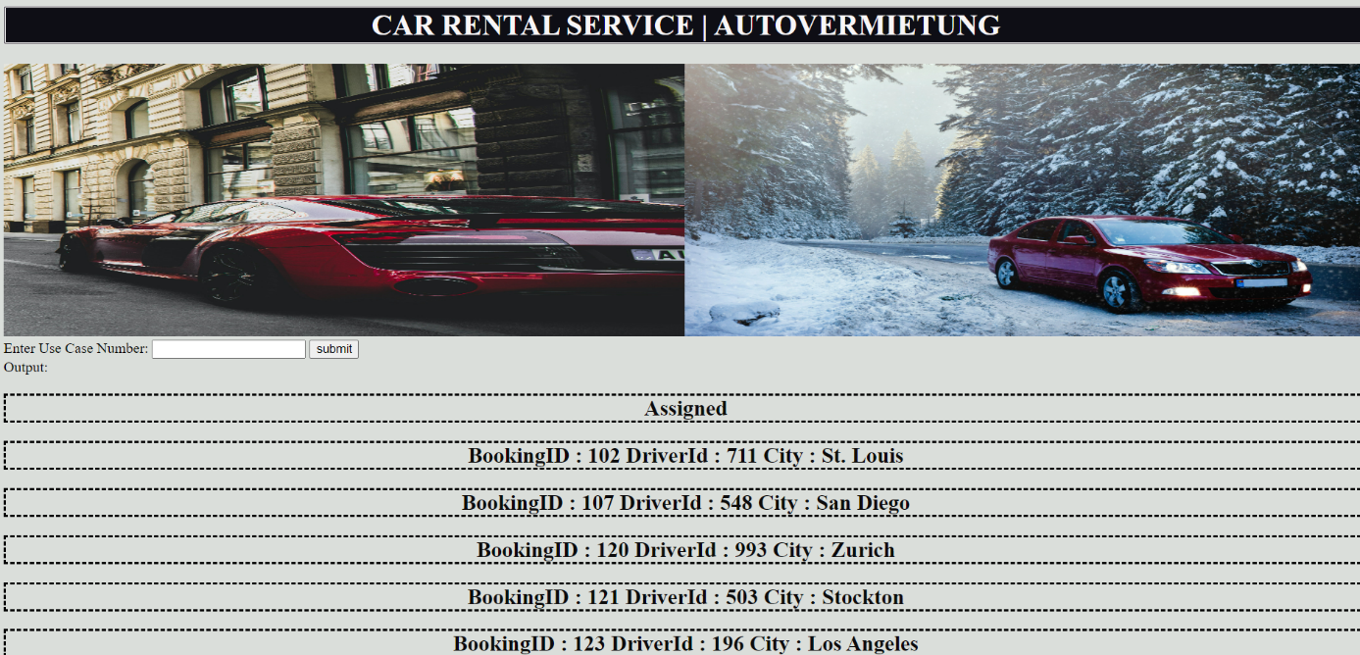

Figure 29: Use Case 5 – Python Script Output

# 4.6 Rescheduling the customer booking as per flight schedule.

## 4.6.1 User Story

If customer will be returning from business trip to his town and want to book a rented car. But sadly, the flight got delayed and unable to inform to the car renting service. Then admin of the car renting service will keep a track of the flight schedule and change the booking time as per the flights.

## 4.6.2 Identified Use Case

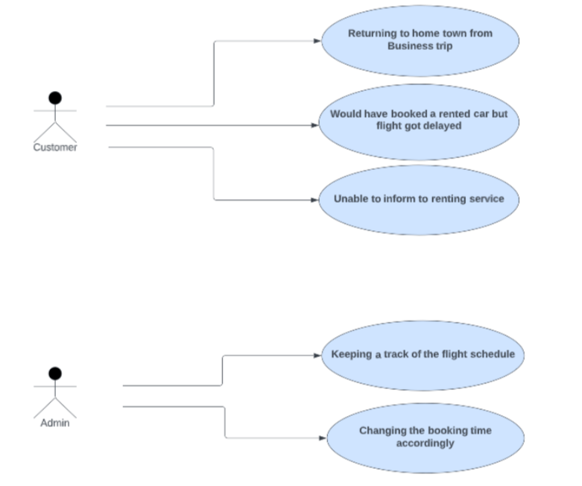

Figure 30: Use Case 6 – UML

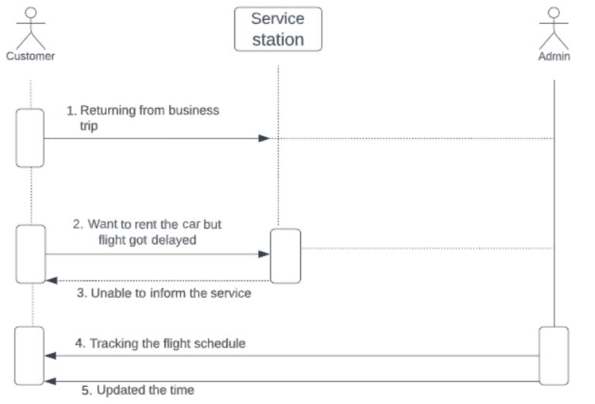

Figure 31: Use Case 6 – Interaction Diagram

## 4.6.3 Actors

• Customer

• Admin (Car rental Service)

## 4.6.4 Description

If customer will be returning from business trip to his town and want to book a rented car. But sadly, the flight got delayed and unable to inform to the car renting service. Then admin of the car renting service will keep a track of the flight schedule and change the booking time as per the flights.

## 4.6.5 Data Flow

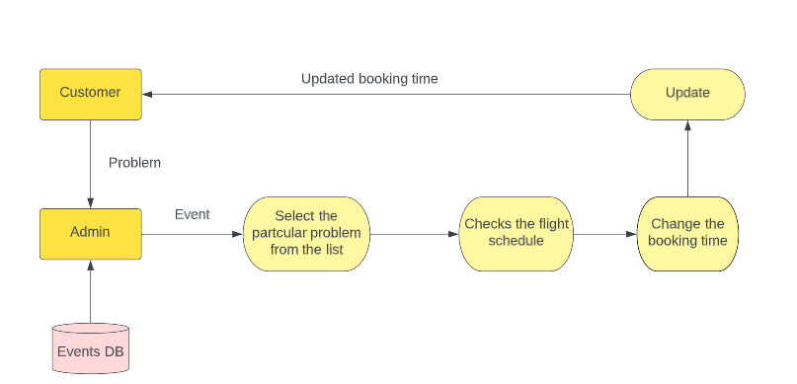

Figure 32: Use Case 6 – DFD

## 4.6.6 Databases

MongoDB

## 4.6.7 Database Used

The document model maps to the objects in your application code, making data easy to work with Ad hoc queries, indexing, and real time aggregation provide powerful ways to access and analyse your data MongoDB is a distributed database at its core, so high availability, horizontal scaling, and geographic distribution are built in and easy to use.

## 4.6.8 Expressions Used

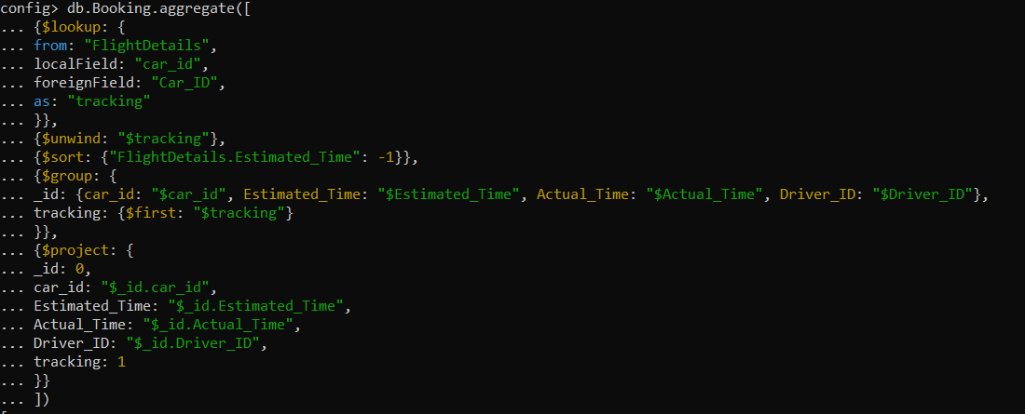

    if useCase == '6':

        #lst2.append('Use Case 2')

        lstcarids = []

        #BookingData = db.Booking_Aditya.find( { "Complaint_Flag": "Y" } )

        BookingData = db.Booking.aggregate([

            {

                "$lookup": {

                    "from": "FlightDetails",

                    "localField": "car_id",

                    "foreignField": "Car_ID",

                    "as": "tracking"

                }

            },

            {

                "$unwind": "$tracking"

            },

            {

                "$sort": {

                    "FlightDetails.Estimated_Time": -1

                }

            },

            {

                "$group": {

                    "_id": {

                        "car_id":"$car_id",

                        "Estimated_Time": "$Estimated_Time",

                        "Actual_Time": "$Actual_Time",

                        "Driver_ID": "$Driver_ID"

                    },

                    "tracking":{

                        "$first":"$tracking"

                    }

                }

            },

            {

                "$project": {

                    "_id": 0,

                    "car_id": "$_id.car_id",

                    "Estimated_Time": "$_id.Estimated_Time",

                    "Actual_Time": "$_id.Actual_Time",

                    "Driver_ID": "$_id.Driver_ID",

                    "tracking": 1

                }

            }

            ])

        #print(BookingData.count())

        #count1 = 0

        #print(len(list(BookingData)))

        lstfin2 = []

        for x in BookingData:

            print(x)

            y = x.values()

            print(y)

            for z in y:

                print(z)

                lstfin2.append(z)

                break

        print(lstfin2,'lstfin2')

        lstfin3 = []

        for x in lstfin2:

            print(x,'x')

            for y in x:

                lstfin3.append(x['Car_ID'])

                lstfin3.append(x['Flight Number'])

                lstfin3.append(x['Estimated_Time'])

                lstfin3.append(x['Actual_Time'])

        for x in range(0,len(lstfin3),4):

            res = ''

            res += f"Car_ID : {lstfin3[x]} "

            res += f"Flight Number : {lstfin3[x+1]} "

            res += f"Estimated_Time : {lstfin3[x+2]} "

            res += f"Actual_Time : {lstfin3[x+3]} "

            lstfin.append(res)

        s1 = set(lstfin)

        lstfin = list(s1)

    var1 = lstfin

    #var3 = lst3

    #var4 = lstfinal

    return(var1)

Figure 33: Use Case 6 – Expressions Used

## 4.6.9 Outcome

Figure 34: Use Case 6 – MongoDB Output

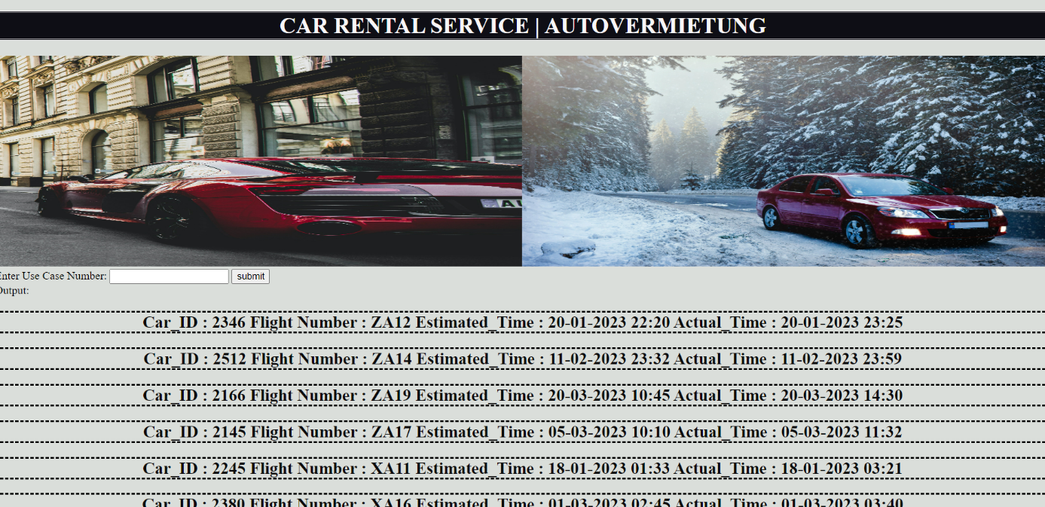

Figure 35: Use Case 6 – Python Script Output

# 4.7 Finding the cars which crossed a specific city.

## 4.7.1 User Story

As an admin, I want to find my cars which crossed a specific city over a specific time duration. I am in collaboration with another company whose ads are stuck on my cars and they want to know the effect of these ads in a specific city.

## 4.7.2 Identified Use Case

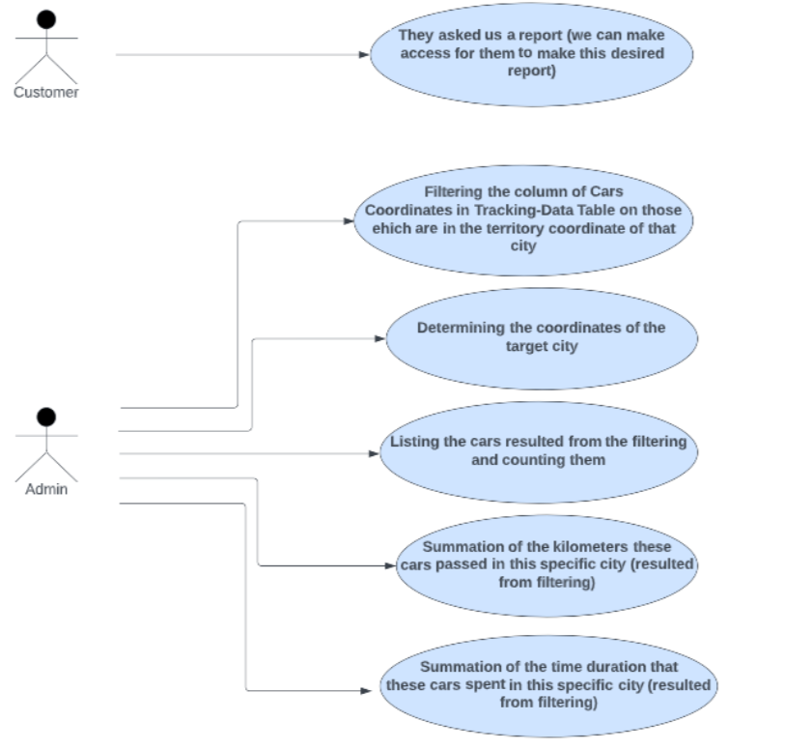

## 4.7.3 Actors

• Customer (Collaborative Company)

• Admin (Car rental Service)

## 4.7.4 Description

As an admin, I want to find my cars which crossed a specific city over a specific time duration. I am in collaboration with another company whose ads are stuck on my cars and they want to know the effectiveness of these ads in a specific city. I have to give a report to that company to show him:

* how many cars crossed the city they need information about;
* how many kilometers they passed in that specific city;
* how long they spend time in that specific city.

Therefore, I have to find the routs that these cars had and create the report for the company using the information (data) of those specific routs.

## 4.7.5 Data Flow

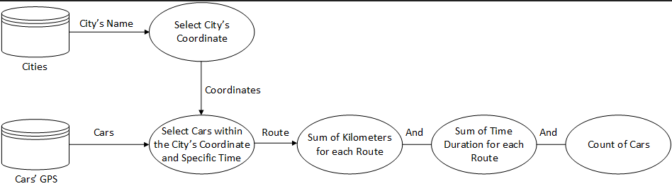

## 4.7.6 Databases

## 4.7.7 Database Used

## 4.7.8 Expressions Used

## 4.7.9 Outcome

# 5. Database

## 5.1 Overall Structure

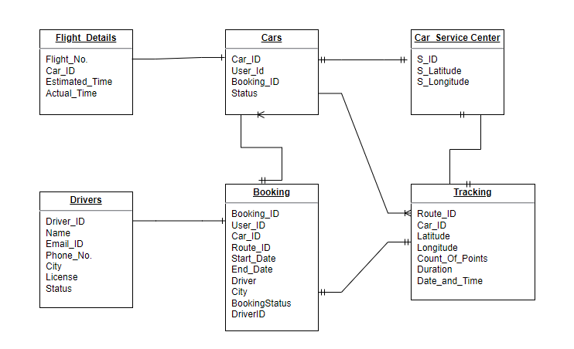

MongoDB stores the records in the document format. Documents in MongoDB are like the ‘objects’ used in the most modern applications and programming languages. Every record (document) inserted in MongoDB is a data structure comprised of field and value pairs. In document, oriented database any type of document can be organized in the simplest way possible.

Key Features:

1. Easily scalable.

2. High availability with replication facility called replica sets.

3. Auto sharding is supported.

4. Schema less.

5. Enables quick access to the data as it uses the internal memory for storing the work set and is best suited for analytical applications.

# 6. Application

## 6.1 Languages Used

Python

Python was used for the implementation of the following use cases:

1. Send help to customer if car breaks down in between

2. Extension of car renting time in current booking.

3. Getting a driver for the customer

Python is best suited for the development of server-side and networking applications, the reason being it is open source and provides cross-platform runtime environment. Python is dynamically typed, and garbage collected. It supports multiple programming paradigms, including structured (particularly procedural), object-oriented and functional programming. It is often described as a "batteries included" language due to its comprehensive standard library. MongoDB driver was utilized (via pymongo library) to implement the above-mentioned use cases.

## 6.2 GitHub path

<https://github.com/kartik03091991/Team_Blue_Car_Rental_Service>

# 7. Evaluation

## 7.1 Outlook

In the Data Engineering module, we studied about various NoSQL database types along with their advantages and disadvantages based on their features and user requirements. We initially developed a user story and identified the actors in it before learning how to model a database. Then we visualized the story in a diagram with users and the action performed on the database. To create it, we used a variety of tools. Then, in order to further query the NoSQL database and complete our user stories, we created a database schema. We developed an understanding of how to configure and connect to various NoSQL databases based on our use cases, and we then used this understanding to implement the answers to our use cases in various programming environments.

## 7.2 Lessons Learnt

It was a challenge to implement and interact between different databases, but we can say that by the end of our project we gained an understanding about each database and how a database can be selected and utilized for information used within an application that would otherwise be very difficult to attain in such a short amount of time.

## 7.3 Possible Extensions

Further features that can be extended are-

- A tie up with a tourist company where we take care of the transportation of the guests across the city

- A website and an application to do the bookings

- Booking of a car for longer durations like 3 months

- To give offers based on customer rating

# 8 References

<https://university.mongodb.com/>

<https://www.youtube.com/watch?v=8jNPelugC2s>

<https://www.youtube.com/c/MongoDBofficial>

<https://stackoverflow.com/questions/3974985/update-mongodb-field-using-value-of-another-field>

<https://www.geeksforgeeks.org/python-removing-dictionary-from-list-of-dictionaries/>

<https://www.w3schools.com/python/python_mongodb_update.asp>

<https://www.mongodb.com/docs/manual/reference/operator/aggregation/cond/>

<https://www.lucidchart.com/pages/landing?utm_source=google&utm_medium=cpc&utm_campaign=_chart_en_tier1_mixed_search_brand_exact_&km_CPC_CampaignId=1490375427&km_CPC_AdGroupID=137488435595&km_CPC_Keyword=lucid%20app&km_CPC_MatchType=e&km_CPC_ExtensionID=&km_CPC_Network=g&km_CPC_AdPosition=&km_CPC_Creative=598116882677&km_CPC_TargetID=aud-1888659850681:kwd-302739930476&km_CPC_Country=9041996&km_CPC_Device=c&km_CPC_placement=&km_CPC_target=&gclid=CjwKCAiA0JKfBhBIEiwAPhZXDx13u06QpUIgMgZCKTmdXnvwVZxhvYvoisiE02QbbRWx4W22xtIK7BoCuacQAvD_BwE>

<https://pymongo.readthedocs.io/en/stable/>